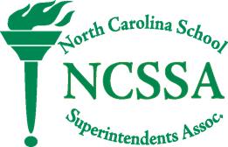
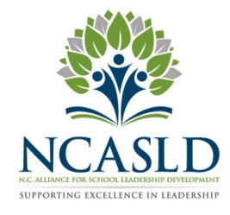
March 24, 2024

North Carolina School Superintendents’ Association Announces the Dr. Samuel Houston Jr. Leadership Awards For 2024

The North Carolina School Superintendents' Association (NCSSA) and the North Carolina Alliance for School Leadership Development (NCASLD) have announced the selection of the following as the recipients of the Dr. Samuel Houston Jr. Leadership Award: Ms. Melody Boyd, Area Superintendent of the Cumberland County Schools; Mr. Drew Cook, Assistant Superintendent of Academics, Wake County Public Schools; Dr. Nicholas King, Deputy Superintendent, Durham Public Schools and Dr. Beth Penley, Assistant Superintendent, Newton-Conover City Schools.

This annual award is presented to graduates of the NCSSA/NCASLD Aspiring Superintendent Program; a program designed to empower transformational education leaders for North Carolina’s public schools.

The award is named in honor of Dr. Samuel Houston who is President and Chief Executive Officer of the North Carolina Science, Mathematics, and Technology Education Center. Dr. Houston served as superintendent of the Mooresville Graded School District for ten years where he opened the first year-round school in North Carolina. Dr. Houston has been a champion for strategic planning, student performance and accountability, meeting the needs of the 21st century workforce, skills for the STEM world, and building education partnerships. Dr. Houston also served as the first executive director of the University of North Carolina Center for Leadership Development.
Dr. Houston was awarded the Jay Robinson Leadership Award as an Exemplary Educator for his outstanding contributions to statewide public K–12 education. He also earned the RJR-Nabisco Foundation's China Breaker Award for implementing educational change. He has been inducted into the Appalachian State University Reich College of Education's Rhododendron Society and East Carolina University's Education Hall of Fame and has received the Distinguished Career Award from the University of North Carolina – Greensboro School of Education. He has also been inducted into the North Carolina School of Science and Math Hall of Fame.
NCSSA Executive Director Jack Hoke said, “Ms. Melody Boyd, Area Superintendent of the Cumberland County Schools; Mr. Drew Cook, Assistant Superintendent of Academics, Wake County Public Schools; Dr. Nicholas King, Deputy Superintendent, Durham Public Schools and Dr. Beth Penley, Assistant Superintendent, Newton-Conover City Schools exemplify the traits that guided Dr. Sam Houston's career in educational leadership. They have a commitment to continuous improvement, high standards of ethical conduct, strategic planning, improving student performance and meeting the needs of the 21st century workforce. I am very proud of these Dr. Samuel Houston Jr. Leadership Award winners and look forward to seeing them progress in their leadership journey in education."

