UNDER EMBARGO UNTIL
February 6, 2023 at 3:00 p.m. EST

Media Contact:
Kolbie Satterfield
615-457-1479
ksatterfield@crispcomm.com

North Carolina Leaders Unite Behind Solutions to Close the Educational Attainment Gap in North Carolina

myFutureNC warns of fewer students completing degrees and credentials while endorsing legislative efforts to address the urgent need for more skilled workers.

RALEIGH, NC – Today, top North Carolina government, education, business, and nonprofit leaders across North Carolina convened in person in Raleigh, and virtually across the state, for The State of Educational Attainment in North Carolina, hosted by myFutureNC. While our state still has much work to do to reach our educational goals, leaders are uniting behind efforts to help more students and adults succeed in the jobs employers are struggling to fill.

Presenters and panelists at the event, including Governor Roy Cooper, Senate President Pro Tempore Phil Berger, Speaker Tim Moore, and myFutureNC leadership, shared an update on our state’s shared educational attainment goal. The goal, unveiled in 2019, would ensure that two million North Carolinians ages 25-44 complete industry-valued credentials or postsecondary degrees by 2030 to provide a skilled workforce for current and future jobs.

Based on the most recent census data, North Carolina remains 444,000 individuals short of reaching the 2030 goal, and already 31,000 skilled workers behind where the state needs to be to stay on track to meet the goal.
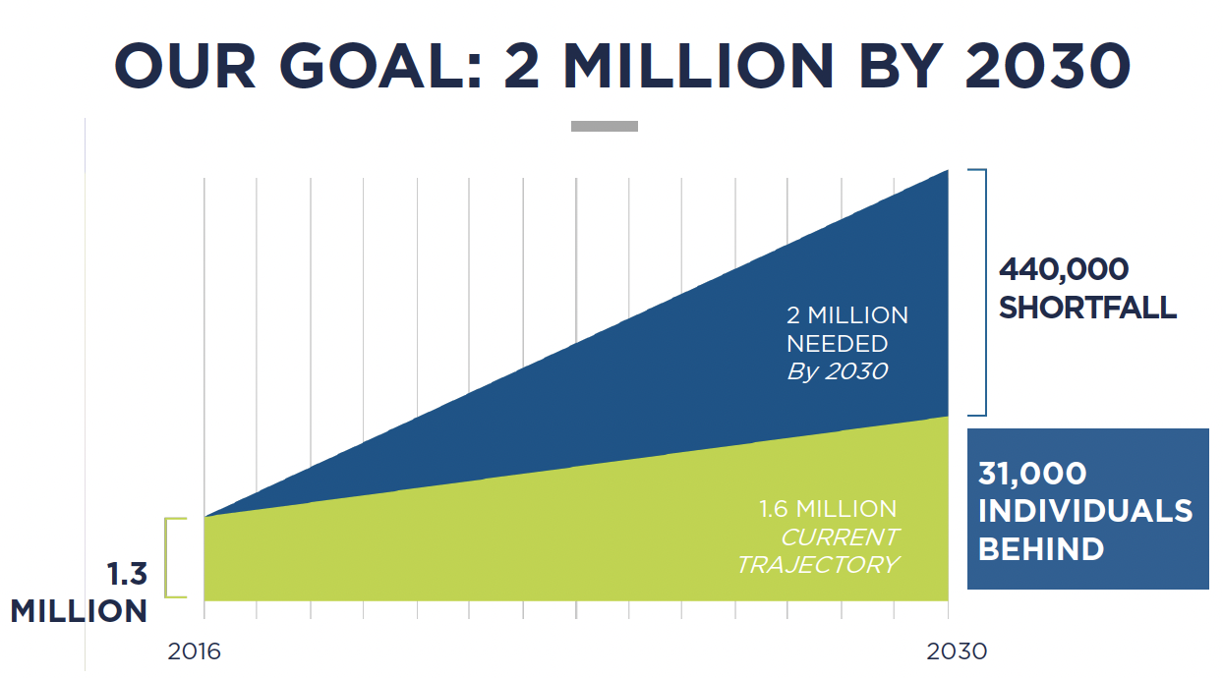

“North Carolina is blessed with a booming economy, yet we still have too many adults that lack the training and skills needed,” said Cecilia Holden, President and CEO of myFutureNC. “We are thrilled that many sectors are coming together today to help us accelerate our progress toward our statewide goal of ensuring two million North Carolinians further their education after high school. This statewide challenge cannot be solved by one group or person. It will take all of us working together.”
The most recent data shows that for every 100 ninth-grade public school students in North Carolina, only 28 earn a degree or credential within six years of graduating high school. Meanwhile, community college enrollment is down 13% since before the pandemic, and jobs requiring a postsecondary degree or credential are projected to increase by 12% by 2030.
myFutureNC and others endorsed two legislative proposals to help move the state toward the 2 million by 2030 goal:

- Career Planning for Every Middle and High School Student – The Department of Public Instruction’s and the State Board of Education’s call for career planning for every middle and high school student will position students better to explore educational and career opportunities years before graduation. The legislative proposal requires an individualized career plan in place for each middle and high school student.
- R.A.I.S.E. Scholarships – R.A.I.S.E. Scholarships which stands for Reinforcement and Investment to Strengthen the Economy will extend the state’s existing support for no-cost pathways to short-term industry-valued credentials. This will encourage more North Carolinians to enroll in programs that connect them to career opportunities in high-growth and/or high-demand ﬁelds that pay higher wages.

“It’s going to take every sector of our society – educators, government leaders, faith-based communities, nonprofit organizations and the greater business community – working together to ensure every K-12 student and every North Carolina adult is ready to meet this important workforce goal,” said Lynn Good, CEO of Duke Energy and Vice-Chair of myFutureNC. “Achieving the goal is not only vital to our business community and the state’s continued economic growth – but most importantly – to ensure better social, economic and civic outcomes for our citizens and communities.”

View a recording of the event.

View the full State of Educational Attainment report.

###

About myFutureNC
myFutureNC is a statewide nonprofit organization focused on educational attainment and is the result of cross-sector collaboration between North Carolina leaders in education, business, and government, and philanthropy. myFutureNC’s mission is to prepare North Carolina for the future by empowering individuals, strengthening communities, and ensuring our economic viability in a global economy. myFutureNC is working across sectors and in communities throughout the state to close gaps in postsecondary attainment, promote alignment between educational programming and business/industry needs, and improve the quality of educational opportunities for all North Carolinians. On February 20, 2019, myFutureNC unveiled its goal and bold vision for the future of education in our state: We will work to ensure that by 2030, 2 million North Carolinians ages 25-44 will have a high-quality credential or postsecondary degree.

